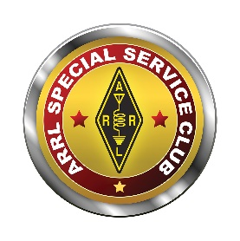  www.arrl.org | 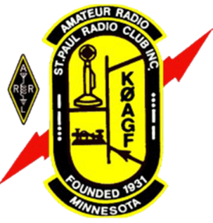 | St. Paul Radio Club  Ground Wave  Jeff Iverson, WB9DAN, Editor  Dale Maroushek, NØPEY, Publisher | KØAGF  www.stpaulradioclub.org  Club Repeaters:  145.310 MHz, 442.450 MHz  114.8 kHz tone  PO Box 9375  North St. Paul, MN 55109
SPRC Nets: Wednesdays 7:30 PM 28.310 MHz USB; 8:30 PM 145.310 MHz FM 114.8 tone
NEWS AND NOTES FOR February 2022 – Volume 82, Issue 2
NEXT MEETING: FRIDAY FEBRUARY 4, 2022
6:00 PM Board Meeting (all are welcome to attend or watch)
7:00 PM Refreshments and Socializing
7:30 PM Business Meeting Followed by Program
Entrance to CDH for our meeting
Meetings are held at Cretin-Durham Hall High School on Hamline and Randolph in St. Paul.
Park in the lot off Hamline near the athletic field. Enter door 21 at the Ryan Stem Center addition. Door 21 will lock at 7:45 so if you arrive after that, please call me to let you in. 612-201-0818 Br. Bob
Program
The February meeting will be a hybrid meeting. That means there will be an in-person meeting at Cretin-Durham Hall (CDH) and a meeting on Zoom for those unable to attend in person. Zoom details are at the end of the newsletter.
The program is not known at press time.
Auction Photos
To see photos from the auction go to: http://www.magicrepeater.net/A-2022.htm
Thanks to Dawn for the photos and George for the web space.
Program Suggestions
An important part of our member meetings, be they on-line or in-person, is our programs. The board plans the programs and we would like your suggestions of what you would like to see. If you would like to present a program, that’s a great idea, too! Please send your suggestions, including potential presenters’ contact information if appropriate, to dk@donkelly.biz (or WA6ZMT@arrl.net, if that’s easier to remember).
CDH Ham Radio Club KF0HOW
The school club roundup will take place 2/14/22 - 2/18/22 which will give the students an experience with HF phone “contesting” (mostly during their lunch hour 11:30 – 12:40)…...how to call CQ; using the phonetic alphabet; how to exchange RST/Class/State reports; and keeping a log.
The vanity call sign W0CDH has been requested.
ARRL flyers WHY YOU SHOULD GIVE AMATEUR RADIO A TRY have been posted around the school with information on the club’s meeting time and stating All ARE WELCOME! Thanks to Allan WA0NLY for obtaining these flyers....enough for next year too!
Submitted by Br. Bob WC0J
From the President – Lou Michaels WD8NOV
I would like to thank the members of the Saint Paul Radio Club that organized and participated in the Annual 2022 Auction at Cretin – Derham Hall. I would like to thank the Auction Chair Dale Maroushek, for holding it all together. Also a big thank you to Br. Bob Walsh for the use of the hall at CDH. It was a good turn out, and Thank You to everyone that attended the auction. Early returns are showing a Large donation destined for the ARRL Spectrum Defense Fund!
Dale’s Details by Dale Maroushek NØPEY
Twas the night before the Auction 2022 and I was worried. Outside afflictions were showing up all over. The temperature was sub normal, and snow was falling with forecast for more. Covid 19.3 something was rolling around laughing at us. Mandates, regulations, and orders were coming and going through the courts so fast, no one really knew what was what.
The six P’s; Prior Planning Prevents Pi## Poor Performance, were endanger of failing!
The Prior was gone, it was a go all the way, too late to back out now.
The Planning was done, but one by one little things were dropping off the screen. They were all legitimate and understandable, we hold no bad feelings to those that choose to stay home.
Prevent the virus, we did what we had too and what we could. Masked up and stayed happy about it. There were many reintroductions because we couldn’t recognize people with covered faces.
Poor choices about saving donations over the years was very evident when we entered the basement tombs at the Brother’s house. Some of that stuff was from before we moved to CDH! I remember trying to sell it back at UST! One person’s junk MAY be another’s treasure, but only very specific collectors would have any interest in a large portion of what we found down there. We must be more selective on what we accept for donations. We can take it all, but only keep what we want, and recycle or trash the rest asap.
Performance was first positively observed in mass, and I am very thankful for the Friday night volunteers. There were some early outs, also understandable, but the 15 to 20 people that showed up made the process move quickly and we emptied the tombs of everything saleable, or not. After many trips forth and back, down and up, we had it all in the sales area. We sorted, matched, moved, selected and tagged all the gear and good stuff, and filled the hallway with Free goodies for those that wanted it. We had to take about 50% of this collection back, but it will be dealt with later, and recycled or used appropriately.
Performance II: Saturday morning we watched the clock tick away and attendance was way-way down. The food stand was ready, the auctioneers were ready, and all the gear and crap was there. Where were the people? We had worked very hard to make it this way. We planned and hoped for a good turn out and some great bidding. We worried Friday night that display space and ticket printing had been underestimated and we would have problems when the outside Hams started bringing in more things for us to sell. Surprisingly, only a couple Sellers brought in more gear, so we had plenty of space.
Performance III: Auction start time was 0930, we let it roll till 0940, introduced our Auctioneers: Jay Bellows K0QB, and Brian McInerney N0BM to start the wheeling and dealing. Ralph Bierbaum N0AWN did some selling later on. Surprisingly, bidding was slow but strong! Good items sold for good prices, poor stuff not so much. Many bidding wars occurred and it made for some fun times. The shortage of bidders, in the 40’s rather than the 70’s, seemed to speed up the sales and bring up the prices. With over 200 lots to sell, we were off to a good start.
We stopped the live auction at 1147 and announced that the silent auction would be closing at 1200, so make your last bids now. That closed and it took us a bit longer to finalize because of some computer network problems. But once resolved, we moved any SPRC lot that had not received a silent bid over to the free area in hopes someone would make it go away. It wasn’t long and everything had been sold, so it was checkout time. This also progressed faster because of the lower turn out.
The volunteer crew once again went into action putting chairs and tables away, cleaning the area and the big job of carting all the leftovers back to the basement for processing later. Deb had dismantled the food stand and helped me load my goodies so we slowly made for the door thanking as many people as we could on the way out. I was exhausted, worn out and hungry. We got home, unloaded, sorted the stuff and cleaned what was needed. I had a couple, you guessed it, Hot Dogs, and tried to stay awake watching the playoff games. Crashed until noon Sunday, watched more playoffs, and started composing this before I forgot about it. It is now Thursday night and time to finish it up.
Performance IV: Where do we go from here? I had planned to pass the white hat of the Auction Chairman on to Ben Otto KE0RFZ, who had been watching and in training for the job. We talked, and he feels not quite ready to take the reins yet. I’m OK with that because this was not a Normal year. We didn’t have the loads of stuff from outside sellers, or the eighty bidders. We had two plus years of donations and collections of gear which was huge. Let’s hope we have a more normal year in 2022 and Ben can get a better grip on the position and move it forward into 2023!
Closing with the Biggest Thank You I can extend to all the attendees and especially the helpers that really made it all possible. Here are a couple pictures from Lou from Friday night, and Dawn and Mark hopefully will have others for us to see later.
Ramblings from the VP’s Work Bench - Kevin Welna - W5LNA
Well, life is still going at Mach 1. One would think that life would slow down once retired. Nope! But at least I’m having fun and enjoying my retirement. Alas It’s going to get worse before it gets better as we have decided to move to the suburbs and are currently looking for a new home. If you know anyone looking to sell a ranch or rambler with a tower in the back yard, please let me know! As much as I am not looking forward to moving, one of the requirements for the new home will be a decent sized area/room in the basement for all my hobbies. I will finally get my own workroom/shack/man cave! With enough area that I can entertain all my interests a once. (Hmm, I wonder if it will be big enough for a train track?)
Another requirement I/we have for the new home is the ability to erect antennas. I have been calling around to the different local governments to see what the rules are for erecting a tower and/or a couple antennas. Trying to get an accurate and complete straight answer is like trying to pull alligator teeth with a pair of pliers. More on this as our search intensifies and the weather gets warmer….
Happily, I have been wrapping up some of my earlier projects so I can start on a few new ones. To that end, the PIXIE is done, and it works! Wow right off the bat it worked. I did not see that coming. I will say that it’s not the most powerful radio I own. But I can hear it on my shack radio when using only a 50-ohm dummy load. It moves my regular radio’s meter about 1 - 1.5 “S” units when being fed with 9 volts DC. I’m hoping it does better once I bump the voltage up to 12 volts. More on this in the future. Anyone else have their PIXIE finished? If so, call me please and let’s share notes. It was a fun project. Enough so that I may build a second one with some modifications. It only took me about 4 hours to solder everything up and I took my time. If you are a seasoned kit builder or are good at soldering, you can probably complete the entire kit in about 2 hours. I still want to spend some time with it and my oscilloscope to see how it actually accomplishes its job. I’m just not sure when I will have the time.
A few things to note on the PIXIE. The tone, while quiet is quite clear and clean sounding on my main Yaesu radio. Going the other way, I can hear the signal from my main radio on the PIXIE, but just barely. The audio output needs amplification. Off to Amazon! I ordered up a small 12-volt DC - class AB - 30-watt stereo audio amp (Thanks Amazon) for $12. I really wanted a kit but could not find one I liked or that was relatively inexpensive. By the way, did you know that you can still buy tubed audio amplifier kits? They are gorgeous and I think one may end up on my work bench next winter……Sorry I’m getting ahead of myself, I gotta refocus on the here and now! OK back to the subject at hand. The audio amp I ordered should be here any day now. Then of course I will need to build (3D Print actually) some speaker boxes and add in speakers to attach to the amplifier. So, even more projects…. I am beginning to think that every project involves the creation/addition of at least two related projects. It’s a never-ending cycle!!
Speaking of 12 volts, I find I am accumulating quite a pile of 12-volt devices/items that seem to need power all at the same time. Looks like one of my other next projects will have to be some sort of fused 12-volt power distribution center. Huh, I guess I should have bid higher on the really nice one that sold for a great price at the silent auction. I’m starting to run out of room on my work bench with equipment and not projects. I think if I am not careful, this will soon spiral out of control! Both the distribution center and speakers will be in my next (I hope) upcoming ground wave article.
My Mr. Mulligan rubber powered airplane is almost done. Of course, in the process of installing the windshield I punched a couple holes in the tissue covering the fuselage which will have to be repaired before its maiden flight. My little plane is quickly turning into a 10-foot beauty. (At 10 feet it looks good, but up close not so much!) Hi Hi
My next plane will be a scratch built (No Kit) model of a Fournier RF4 motor glider with a retractable nose wheel. Oh yea, time to break out the CAD program and the 3D printer since no one makes such a thing. I do so love integrating multiple hobbies into a single project! Another quick side note, as I am writing this, my doorbell rang and it was the UPS man delivering a kit I forgot I had ordered a few months ago. It’s a kit for a de Havilland DH.82 Tiger Moth. Life just gets better and better. I really need a bigger house.
My CW Ops training is back on and I am quite enjoying it. It’s a bit more work this semester, but I think it will pay dividends when I am done. Finger crossed I will be on the air making contacts by the end of February. No, not with the PIXIE as it is set up for a straight key or external keyer. I sold my keyer when I got my new radio since it has a built in keyer. But now that you mention it, I do have a couple of left-over Arduinos and I did see an article and schematic online for making your own keyer. Plus, there is a great one in one of my project books, “Microcontroller Projects for Armature Radio” by Jack Purdum W8TEE. The project is for a programable CW messenger that’s also a keyer. What the hell let’s add it to the list of projects!
Since I finally made it back onto Ham radio stuff, let me keep going with that train of thought. Have you heard of Hams in the Park? It’s a gathering of hams every month on the 2nd Saturday. They usually meet at around 11am-12pm at Long Lake Regional Park in Shoreview and go till about 3pm. If the weather is too cold, they instead meet for “Hams in the Tavern” same date and time, but they meet at Welches Big Ten Tavern in Arden Hills where the food is good and the prices are reasonable. Both gatherings are very relaxed with anywhere from 3 to 15 hams and wanna be hams. It’s a great way to put a face to a voice/call sign and to see/play with different radios and try them. It will get you reenergized to get on the air and it’s also a great way to meet fellow hams. More info can be had at the following web page: https://wp.hamoperator.com/?page_id=777 It’s a great way to warm up for Field Day.
Speaking of Field Day, why not come out and participate? Yea I know it a bit early to think about an event at the end of June, but I am already working on possible food offerings for the event. There may be some pleasant surprises this year. I going to try anyway. My mom said never trust a skinny chef. If you ‘ve seen me, then you know I CAN be trusted. Hi Hi
One Last thought, there are over 60 paid up members in our club and around 100 members in total. Currently about 12 members are doing all the work. We need you to volunteer and help out. You don’t need to do a lot. Just a little extra assistance here and there will help keep the current 12 from burning out. Every little bit helps greatly. Part of being in a club is offering your assistance. There are duties that could be handled by a member\volunteer that would entail less than 2-4 hours a month of your time but would benefit both the club and your fellow members immensely. Please consider contacting a board member and offer your time. Otherwise, this club like so many others will start to fade away and things like the auction, field day, Ground Wave and even the hobby itself may become a thing of the past. It’s up to us to keep it alive and flourishing.
I’ve attached a few photos for your entertainment.
Completed PIXIE
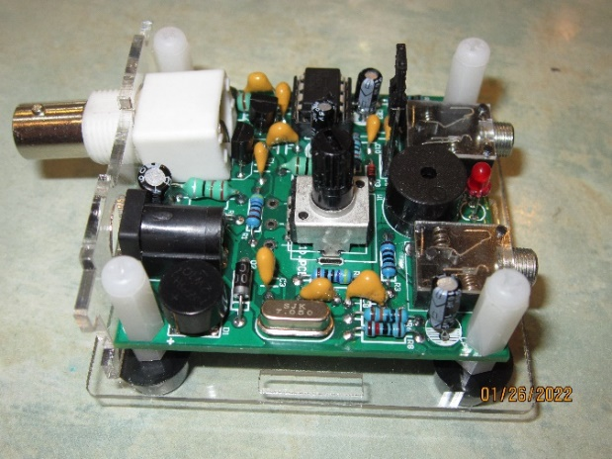
Mr. Mulligan ready for prop and rubber band 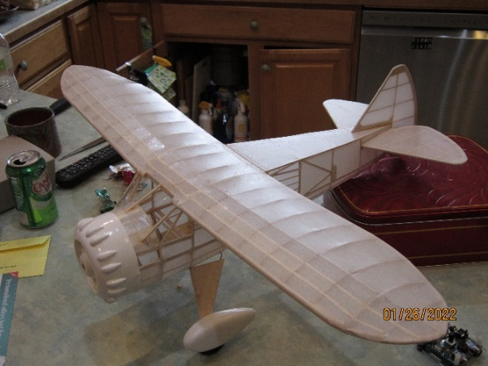

2” speaker enclosure (1 of 2) printed on the 3D printer.
No idea how they will sound
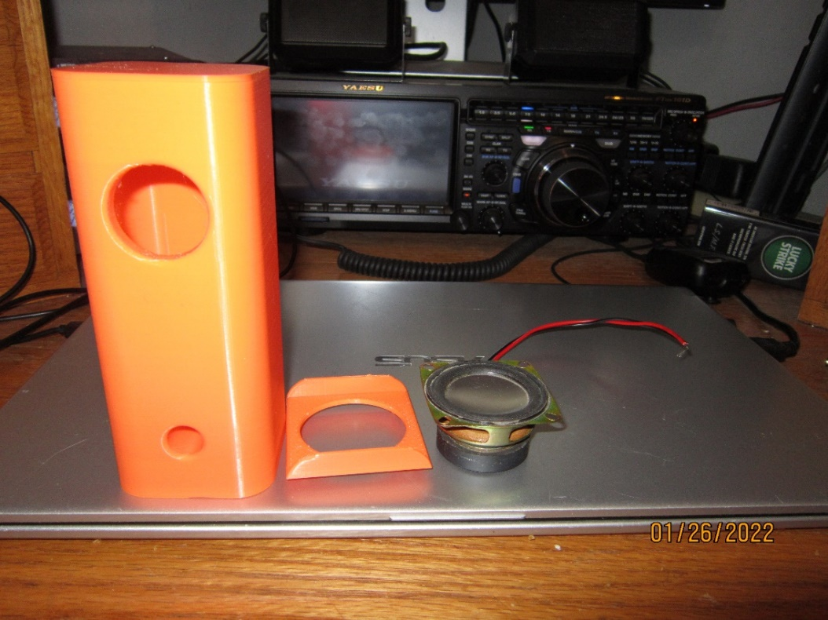
Extra Extra Read all about it by Pete Guldan KDØSQJ
I have started to study for my Extra several times. I have purchased several of the study materials, some of them more than once. I still haven't taken the test other than after I passed my General where I got half of the Extra questions right. Of course the math works that the other half were wrong, and to pass I would have needed 74% or 37 out of 50 for you math people. What I need to do to advance to the Extra is to be consistent with my studies and schedule the test. If you are at all like me and would like to join me and advance from General (or Advanced) to Extra, or if you are already an Extra and would like to brush up on the material, please join us online for our Sunday afternoon study group starting February 6th at 2PM on Zoom. The cost will be free except for the15 dollar fee when you take the test with us on May 7th. We will have 12 weeks (no class Easter Sunday April 17) so even those of us with busy schedules should be able to pass with flying colors. We will be using the ARRL book and the club is purchasing 6 of the books which should be at the February 4th club meeting. To sign up send me an email kd0sqj@arrl.net with your details, concerns etc. so we can help each other out and get this thing passed or reviewed so we can at least pretend we know what we are doing. Now I just need to figure out this Zoom hosting thing.
January Board Meeting Minutes – by Art Thell, NØIWQ
Board members present:
Kevin Welna-W5LNA Ben Otto-KEØRFZ (Zoom) Art Thell-NØIWQ Br. Bob Walsh-WCØJ Don Kelly-WA6ZMT (Zoom) Allan Klein- WØNLY (Zoom)
Lou Michaels WD8NOV

Also present:
Dale Maroushek-NØPEY Jay Maher-NJØM Jeff Iverson-WB9DAN (Zoom)
Dave Fisk-NØMK (Zoom) George Power-KØGCP

Housekeeping note: The entrance we are to use is Door #21 on the south side of CDH. This door locks at 7:45 PM. Late access can be effected by calling Br. Bob at 612-201-0818.

The CDH Radio Club application for license is approved with Br. Bob Walsh as Trustee.
Callsign is: KFØHOW

6:10 PM: President Lou called the meeting to order.
Old business:

Secretary’s report: Request for added agenda items: Dale Maroushek requested that the “Google” link be removed from the old SPRC website. Don Kelly & Jay Maher will fix.
Request for motion to approve minutes from December Board Meeting. Motion by Br. Bob, Seconded by Kevin. Approved.

Treasurer’s report:
Allan Klein: General Fund: $8374 Education Fund: $1382 Repeater Fund: $982

Repeater report: Dale: Working fine.
Dale also reported that he has updated the club volunteer list and will distribute.

Circuit Builders: Kevin, Ben:
Br. Bob accepted (6) kits for CDH students to build.
Members with kits will build at home and possibly meet to discuss issues.

Research By-laws regarding increasing the board member count.
Art, Kevin will report next meeting.

Dale asked if a label could be made to identify SPRC equipment with a serial number to identify the item on inventory. Art noted that he could produce produce something from Avery Labels.

MOU between SPRC and CDH:
Br. Bob presented the latest version. A discussion followed regarding some, mostly grammatical issues. These were documented by Br. Bob. CDH will re-write and SPRC will sign the final document at the Auction.

Don presented a motion to add equipment coverage to the SPRC insurance policy with ARRL.
Allan spoke highly of this move. Dale mentioned the fact that the club now has considerable equipment atop CDH, exposing SPRC to potential storm losses and related damage.
The move to add was presented by Don, seconded by Lou.
Motion passed.

Auction:
Auction committee and board members are requesting club-wide help in setting up on Friday, January 21st starting at 4:30 PM. Help is needed to move equipment from storage as well as arrange and set up the area.
The Auction will commence at 8:30 AM on January 22.
Several alternatives were proposed to assure computers and software will be functional.

New Business:
Regarding POTA (Parks on the Air):
Kevin reminded attendees of the ongoing Hams in the Park.
Art noted that NPOTA and POTA are ongoing efforts and a great opportunity for operating. This is an extension of the NPOTA effort of several years ago. Details can be found on the POTA and NPOTA websites.

Field Day: Dale reported that work is being done on generators and lighting to un-complicate that part of the effort. Eric (NY9D) will report on this as the March program.

Other club participation: Brian NØBM reported that there are opportunities for programs by working with other clubs. A volunteer liaison for this is needed. Don Kelly volunteered to get some inter-club communication going.

Art moved to adjourn. Seconded by Kevin. Meeting adjourned at 7:23 PM.
January Membership Meeting Minutes – by Art Thell, NØIWQ
Lou (WD8NOV) called the meeting to order at 7:38 PM.

Approval of December Minutes. Moved by Lou. Seconded by Kevin. Approved.

Treasurer’s Report given by Art
Fund Balances: General Fund: $8374. Education Fund: $1382. Repeater Fund: $982.

Repeater report: Dale: Working fine.

Circuit Builders: Kevin.
Pixie kits: Gave (6) to Br. Bob for students. Requirement is to build and get on the air.
Regarding SPRC members, for now we will have to build them individually and possibly meet someplace to discuss issues. The hope is that, when the STEM center is complete and operational it will be available for use.

Education: Pete.
Proposed a class for Hams to upgrade to Extra Class. Soliciting interested Hams. Hopefully classes will commence February 6. Target date for the test is May 7.
ARRL Extra Class Training Manual will be used.
Don K. will host the license classes on Zoom.

Pete proposed that SPRC Radio Club purchase (6) manuals for use. Moved by Dale. Seconded by Kevin. Approved. Allan will manage purchase.

Reminder was made of the MN QSO Party on Feb. 5. CDH could participate in this event.

Auction: Set-up Fri. January 21 at 4:30 PM. Help is needed. Auction is January 22 commencing at 8:30 AM. Runs until finished.

Wadena Hamfest January 8. Cancelled.

Parks on the Air: POTA and NPOTA. Can contact Kevin or Art for information.
However both have websites with excellent information. Fun and easy to participate.

Field Day 2022:
Set up June 24. Operate June 25-26.

Move to adjourn. Motion by Ralph. Seconded by George.
Adjourned at 8:22 PM.
Editor’s Notes – by Jeff Iverson, WB9DAN
I would like to remind everyone about our St. Paul Radio Club Facebook page. We have over 100 members who are interested in what we are doing. Find the group and ask to join.
Remember, contributions to the Ground Wave are always welcome. Send them in a Word document (.docx) or Open Office document (.odt) as an email attachment to jaiverson@juno.com. Deadline is one week before the next meeting.

Officer Contact Information
President | Michaels, Lou WD8NOV | louthephotoguy@gmail.com | 612-638-8159
Vice President | Welna, Kevin W5LNA | kwelna@gmail.com | 651-354-5515
Past President | Kelly, Don WA6ZMT | dk@donkelly.biz | 651-276-4838
Treasurer | Klein, Allan WØNLY | allankmn@cs.com | 612-720-1324
Secretary | Thell, Art NØIWQ | thellaj@comcast.net | 651-457-5533
Member At-Large | Otto, Ben KEØRFZ | ke0rfz@gmail.com | 651-352-9590
Member At-Large | Walsh, Bob WCØJ | brw.fsc@gmail.com | 612-201-0818

Zoom Information
Simply click the link below (or copy and paste link into your browser if that doesn’t work) or call in from any phone. If you’re not familiar with Zoom and would like to arrange to practice, text Don at 651 276-4838 or email dk@donkelly.biz.
Since they are all the first Friday, I’ve just scheduled all meetings on the first Friday until May. The link will be the same for all of them.
SPRC is inviting you to a scheduled Zoom meeting.
Topic: SPRC Monthly Meeting
Every month on the First Friday
Feb 4, 2022 06:00 PM
Mar 4, 2022 06:00 PM
Apr 1, 2022 06:00 PM
May 6, 2022 06:00 PM
Please download and import the following iCalendar (.ics) files to your calendar system.
Monthly: https://us02web.zoom.us/meeting/tZcoc-uqpjosHNYgigyhIdJi19w4O3qkrK_G/ics?icsToken=98tyKuGr qz8oGNyUth-FRpwqGY-ga-rxiH5dgo1kmxbiGih6Zin_Z7tVZp0sAdPC
Join Zoom Meeting
https://us02web.zoom.us/j/83542281662?pwd=QjhLNGhBZ2RuaUxrMWV4Z3laSWRLZz09
Meeting ID: 835 4228 1662
Passcode: 440211
One tap mobile
+13462487799,,83542281662#,,,,*440211# US (Houston)
+12532158782,,83542281662#,,,,*440211# US (Tacoma)
Dial +1 312 626 6799 US (Chicago)
Meeting ID: 835 4228 1662
Passcode: 440211
Find your local number: https://us02web.zoom.us/u/kdYAGlKiIf

SPRC Calendar
Fri Feb 4 6PM SPRC Board meeting, Commons Meeting Room, John R. Albers Center, Cretin-Derham Hall High School. *
Fri Feb 4 7PM Socializing followed by 7:30 PM SPRC Membership meeting. Commons Meeting Room, John R. Albers Center, Cretin-Derham Hall High School. See Page 1.
Sat Feb 5 10AM VE testing. Galilee Lutheran Church. 145 N McCarrons Blvd, Roseville, MN 55113. Reservations required. No walk-ins until further notice. Contact Leon Dill, WØCOE@arrl.net or 651-425-0338.
Sat Feb 12 9AM-1PM St. Cloud ARC COVID Fever Reliever Hamfest 2022. St. Cloud Armory, 1710 Veteran’s Drive, St. Cloud, MN
Sat Feb 19 9AM SPRC Breakfast. Denny’s, 1664 University Ave, west of Snelling.

Fri Mar 4 6PM SPRC Board meeting, Commons Meeting Room, John R. Albers Center, Cretin-Derham Hall High School. *
Fri Mar 4 7PM Socializing followed by 7:30 PM SPRC Membership meeting. Commons Meeting Room, John R. Albers Center, Cretin-Derham Hall High School.
Sat Mar 5 10AM VE testing. Galilee Lutheran Church. 145 N McCarrons Blvd, Roseville, MN 55113. Reservations required. No walk-ins until further notice. Contact Leon Dill, WØCOE@arrl.net or 651-425-0338.
Sat Mar 19 9AM SPRC Breakfast. Denny’s, 1664 University Ave, west of Snelling.
Sat Mar 19 8AM– Noon Midwinter Madness Hamfest, Buffalo Civic Center, Buffalo, MN

* Depending on business to be considered, Board Meetings are sometimes held electronically. Check with a Board member beforehand to confirm a meeting.

