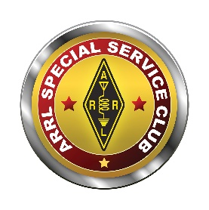  www.arrl.org | 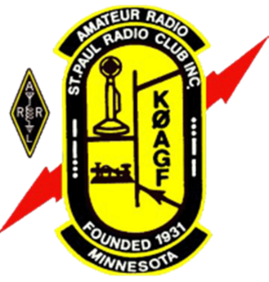 | St. Paul Radio Club  Ground Wave  Jeff Iverson, WB9DAN, Editor  Dale Maroushek, NØPEY, Publisher | KØAGF  www.stpaulradioclub.org  Club Repeaters:  145.310 MHz, 442.450 MHz  114.8 kHz tone  PO Box 9375  North St. Paul, MN 55109
SPRC Nets: Wednesdays 7:30 PM 28.310 MHz USB; 8:30 PM 145.310 MHz FM 114.8 tone
NEWS AND NOTES FOR March 2022 – Volume 82, Issue 3
NEXT MEETING: FRIDAY March 4, 2022
6:00 PM Board Meeting (all are welcome to attend or watch)
7:00 PM Refreshments and Socializing
7:30 PM Business Meeting Followed by Program
Entrance to CDH for our meeting
Meetings are held at Cretin-Durham Hall High School on Hamline and Randolph in St. Paul.
Park in the lot off Hamline near the athletic field. Enter door 21 at the Ryan Stem Center addition. Door 21 will lock at 7:45 so if you arrive after that, please call me to let you in. 612-201-0818 Br. Bob
Program
The February meeting will be a hybrid meeting. That means there will be an in-person meeting at Cretin-Durham Hall (CDH) and a meeting on Zoom for those unable to attend in person. Zoom details are at the end of the newsletter.
The program speaker is Eric Westgard, NY9D. He is the chair of medical communication volunteers at the Medtronic Twin Cities Marathon, Red White and Boom Half Marathon, and the Loppet Winter Festival. He was instrumental in the construction of the MN Statewide Packet Network, Mn Statewide D-Star Network and Reflector 632A, and a new 5 GHz TwinsLAN mesh network covering both cities as well as several repeaters. He is a regular contributor to the ARRL EmCom Newsletter, as well as QST and CQ Magazines and the TAPR Journal. He has spoken at Dayton on EmCom and QRP topics and at TAPR. His most recent project is organizing the purchase of fifteen 30’ class tower generator trailers, which as a group now have a formal Ham Radio relationship with MNVOAD. Erik is a retired from AT&T Principal Consultant and is a Senior Community Faculty member in the College of Management at Metropolitan State University.

Program Suggestions
An important part of our member meetings, be they on-line or in-person, is our programs. The board plans the programs and we would like your suggestions of what you would like to see. If you would like to present a program, that’s a great idea, too! Please send your suggestions, including potential presenters’ contact information if appropriate, to dk@donkelly.biz (or WA6ZMT@arrl.net, if that’s easier to remember).
CDH Ham Radio Club W0CDH – Br. Bob, WC0J
The February School Club Roundup was held the 14th – 18th. Students got a quick lesson on how to handle a pile-up. Photos are being taken for a display board, a posting on the school’s website, and a future school article about the club. A computer (most likely used) will be the next purchase.
Dale’s Details by Dale Maroushek NØPEY
I find myself with little to expound upon this month. True, we have our first live (zoom) program in many months, and another one next month. That means we still need programs for the April and May meetings, plus one for the Banquet. Anyone have a presenter that we can contact?
The Wednesday night nets have been running smoothly and information is usually exchanged every week. We can always use more check-ins and volunteer net controls would be great.
I did have to run down to Cresco, IA for my uncle Ray’s funeral (96) on the 18th/19th, and since I have a 2nd cousin there, Bruce Blaser, N0HD, who is a member of their club, I grabbed an HT and Manual as we left. I figured on getting on the local repeater and chatting up the neighborhood. Now I do most of my HT programming via computer link, so reading the manual was on the bill. I tried for a couple hours Friday night to plug in the tone without any luck. I crashed and tried again Sat morning. So I finally settle in on the step by step push button procedure on page 107. I follow them, one, two, and three and then guess what four says. Go back to page 47 and follow the steps to save it! Couldn’t they just repeat the last steps and make it easier?
I missed February breakfast and will miss March too. It is the same Saturday as Mid-Winter Madness out in Buffalo. As usual, we will be needing table sitters to cheerfully entice prospective members to join the club. Makes a great place to stash your coat and hot purchases and all you have to do is take an hour and man the booth. Let me know if you will be available.
Our Extra Class Zoom meetings have been helpful to get the guys started, but now the hard parts are coming up. Electronics from the ground up and more. I’m sure we will have more questions in the coming weeks.
At the last meeting, Kevin W5LNA, my new food side kick, asked if there was any set menu for the Field Day K0EATS station. He was told no, whatever he wants to do. This made me think back about all the foods we have served over the years, from breakfasts to steak dinners. Might have to go back and write something on that. In the meantime, I wonder what Kevin is thinking about? Still looking for that refreshment chair to take over the liquid side of the weekend. I’ve written it up before, we can furnish the coolers, and you supply the beverages and keep them iced twice or more and charge the club for only used inventory. Not as hard as you think, and your family loves the leftovers.
Someplace in this issue, I’m hoping to see the results of the 2022 Auction. We did our best to clear the chambers of current stock and be ready for new items from donations and Estates. Going forward, we will be more selective on what we accept, or at least save it a trip down into the tombs and put it right to the dumpster.
Ramblings from the VP’s Work Bench - Kevin Welna - W5LNA
Have you ever noticed that one hobby leads to another? I’m staring at my shack radio while listening to my 3D printer humming along printing out an enclosure for a second PIXIE kit I need to build. Next to the printer is a work bench with another stick and tissue model plane in the process of being built. The building board is slightly askew because the soldering station is in the way. Next to the work bench are a number of plans for other models waiting to be built. Now granted I am hobby ADHD but even if I were not, I believe that there would be something else on the workbench to occupy any down time from the radio. I have also noticed that I am not alone in the issue of hobby ADHD. Think of the number of Hams you know that are also into model trains, photography, painting, model airplanes, shooting, electronics, playing a musical instrument or woodworking....and the list goes on and on! And not just interested in the hobby but active and in many cases quite accomplished. Wow!!
Take my interest in Ham Radio. It sort of started back in the 80’s when I was heavily into RC planes. Back then the radios were on 27 and 72 MHZ and used AM modulation. They were prone to RFI (Radio Frequency Interference) and occasionally a flier would lose all control of his/her plane and crash. But some of the flyers never seemed to have this issue because they were using FM radios on 75 MHZ. I wanted that! Well, I did until I found out that I would have to learn Morse Code and take some tests to get the license to transmit on that band. Since I was back in school, I decided that taking on additional learning was not for me. So, I stayed on 72 MHZ until the last of my planes crashed either due to RFI or doing something dumb. OK mostly doing something dumb.
Anyway, most of the fliers that were on 75 MHZ were also Ham radio guys and they would talk about contacting people all over the world and chatting with them. To me this sounded grand and quite interesting. Since I was in school for Electronic Repair it was even more enticing. Alas there was that pesky Morse Code requirement so again I let it drop. Step forward 30+ years and I am sitting in my office, and I hear some beeping which reminds me of morse code, and I think Hmm maybe now I can take on a new learning endeavor. I start researching what is needed for a Ham Radio Operators license. Lo and behold NO MORSE CODE REQUIREMENT!!!
Hot damn I’m going to be a Ham Radio guy! A little bit of studying and I pass both my Novice and General exams and then the learning really begins. How do radios really work? What’s happening inside that box? How do antennas work? Can I build my own radio? Etc. Then there is; Where do I place the antenna? What are the code restrictions for an antenna? How to I secure the antenna? What antenna should I buy? What radio should I buy? Why is propagation so bad? And the list goes on and on. You see one thing naturally leads to another. What it boils down to is as you get deeper into a hobby, new problems arise that need a solution. I believe this is where Ham Radio people excel. That is finding a simple, economical yet effective solution to a problem. This ability whether natural or leaned is one of the traits of every Ham Radio guy/gal out there. This ability then spills over into other facets of our lives and other hobbies /interests.
How does this evolve? Learning and the willingness to research and learn new things. Technicians want to become Generals, Generals want to become Extras. To get there you must be willing to research, ask questions and learn new stuff. In the process you meet people and develop bonds and friendship. This leads to conversations outside of ham radio which leads to exposure to other interests which of course leads to Hobby ADHD!! It’s a vicious circle.
For instance, getting back to RC planes, I’m chatting with a fellow ham on the radio, and I mention that I am building a rubber powered Mr. Mulligan kit I found while cleaning up my basement work area in order to clear enough space so I can fiddle around building some Arduino and Raspberry PI circuits for Ham Radio. Somehow the conversation evolves into model R/C planes and building/flying model R/C planes. Turns out this guy still flies RC planes. One thing leads to another and now I am getting back into RC planes. What the heck!!!! Worse yet, since I rather enjoyed the process of covering the stick and tissue models with tissue and dope, I decided to go old school and start covering my R/C planes with silk instead of the newfangled iron on coverings. Remember what I said about researching and asking questions and problem solving? Well, I am now corresponding with a silk importer that also sells dyes for coloring silk. It seems this is an art form that has a relatively low entry cost. Another hobby? To accomplish my goal at a reasonable cost I will need to build all the fixtures needed for the dying process. To this end, I am now designing and building a silk stretcher, specialized clips to hold the silk while dying it and a fabric steamer to “set” the dye. (I am now somewhat conversant on silk dyes and the dying process.) More problems and more solutions! I have no doubt that designing and build these fixtures will present their own set of unique and frustrating problems that will require resolution. I am looking forward to the learning ahead of me.
Alright back to Ham Radio. Earlier I talked about my work bench and building a second PIXIE kit. Why do I need two? Well its actually only one. It seems that while experimenting with the first PIXIE kit, I burned up the output transistors by leaving it on and transmitting while taking measurements with my digital oscilloscope. I bought the scope to help me understand what is actually happening on the circuit board and thereby increase the depth of my knowledge with all things Ham Radio. Sometimes learning can cost a bit more than expected. Oh well I do enjoy building electronic kits. I guess this must be a win/win situation after all.
Where am I going with all this? I’m not really sure….Hey the title says “Ramblings from the VP’s Workbench”. LOL
OK, I guess it’s a call for all of you to stretch your brain and learn something new preferably involving Ham Radio but not necessarily. The latest term for it is “Lifetime learning”. (I call it Hobby ADHD) It is the one thing that you need to do to be a true Ham. Plus, it has its benefits. Well maybe not on your pocketbook, but a number of studies have found that continuing to learn as we age helps ward off / delay Alzheimer’s and cognitive memory loss:
https://www.alzdiscovery.org/cognitive-vitality/blog/cognitive-enrichment
https://www.nia.nih.gov/health/preventing-alzheimers-disease-what-do-we-know
https://www.hopkinsmedicine.org/health/wellness-and-prevention/does-higher-learning-combat-dementia
And let’s face it we ain’t gettin’ any younger.
Furthermore, it’s a great excuse you can give to your XYL the next time she gets upset at your latest purchase. You can say, “No really honey it’s a cure for Alzheimer’s. Trust me. Here I’ll show you the research.” LOL
Until next month,
73
Kevin Welna
W5LNA
P.S. I tossed in a couple of pictures for your amusement.
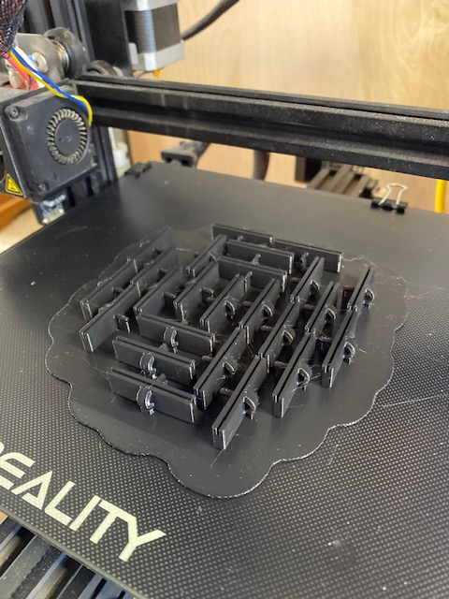
Silk Clips I designed made on the 3D printer

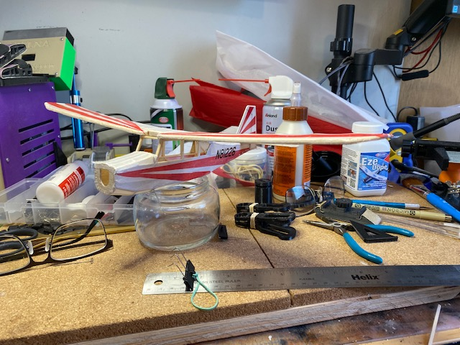
Latest Stick and Tissue model of a Citabria. It’s almost done! Just add warm weather!
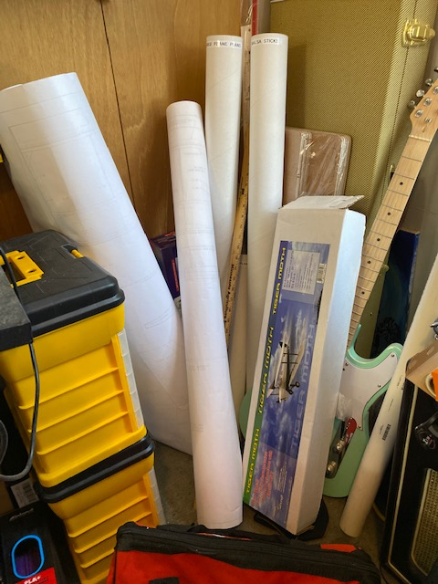
Plans and kits just waiting for my attention. Yes, I own an electric guitar. No, I don’t know how to play it. Not well anyway. But I can play it REALLY LOUD!!
Math gone Wild. By Pete Guldan KDØSQJ
Our Extra study sessions are chugging right along a chapter at a time. Okay so here's a question for all you math nerds. Math is hard enough using normal numbers. Why do you have to come up with imaginary numbers? When French math dude Rene Descartes used that as a derogatory term in the 1600's I think he was on to something. If all the math dudes and dudettes want to get all imaginary they should imagine a better way to explain it to us non math nerds. Big Thanks to all of you who are helping us study this material. I currently have 3 holes in the roster and am looking for help leading chapters 5, 7, and 8. If you or someone you know are knowledgeable in Components and Building Blocks, Radio Measurements and Performance, or Modulation Protocol and Modes please drop me an email at kd0sqj@arrl.net Thanks.
January Board Meeting Minutes – by Art Thell, NØIWQ

Board members present, (Absent or virtual):
Lou Michaels (Pres.)-WD8NOV Kevin Welna (V. Pres.)-W5LNA
Art Thell (Secy.)-NØIWQ Allan Klein (Treas.)- WØNLY (excused)
Br. Bob Walsh-WCØJ Ben Otto-KEØRFZ
Don Kelly-WA6ZMT (Zoom)

Also present:
Dale Maroushek-NØPEY Jay Maher-NJØM Jeff Iverson-WB9DAN (Zoom)
Pete Guldan-KDØSQJ John Crabtree-KCØG Curt Trout-ACØCT
6:18 Pres. Lou called the meeting to order.

Br. Bob WCØJ, trustee of the new CDH Radio Club, has informed us that the new (vanity) callsign for the CDH Radio Club is WØCDH

Secretary’s report
Art moved that the board approve the January minutes. Seconded by Kevin.
Passed with one adjustment. That adjustment has been made.

The signed copy of the MOU between CDH and SPRC was received and will be filed by me.

Art presented a sheet of (60) serialized equipment labels for use in ongoing equipment inventory. They were adjudged satisfactory and subsequently passed on to Ben. Art will also craft an inventory spreadsheet from Ben’s specs.

SPRC By-laws review:
Art reported and Kevin confirmed that they had met originally in January to review the document. That copy contained modifications. A clean document was then forwarded to us by Dale. He attested and Don confirmed that this second document was the one that was previously adopted by the Board of SPRC. After review we found this document to be a well-crafted, concise work that can serve as our main governing document until such time as when a situation requires a specific change. It has been entered into our file of SPRC Official Records.

Some discussion centered on whether the number of board members should be increased. It was noted, however, that it is probably easier to recruit for a specific one-time need than for a two-year-plus commitment. No motion was offered.

Treasurer’s report: Absent.

Repeater report: Dale reports it is working.

Google link to old SPRC website. Dale is following up on this with several members. Don, Jay, and Curt offered some input and agreed the issue needs further pursuit to solution.

Circuit Builders, Pixie units:
Kevin reported that the Pixie unit he built works—barefoot. There appear to be some issues when coupled to a homebuilt amp, however.

Br. Bob reported that the CDH Club is not yet ready for builders’ classes. His target is autumn, 2022. Some suggestions were made regarding classes covering basic building skills as soldering to boards, etc.

Education—upgrade: Thank you Pete KDØSQJ
Pete reported that the Extra Class program is up and poised to start on February 6, 2022 with a total of 12 classes. He needs a person (Elmer) to lead each chapter. The (6) Extra Class Manuals have been received and can be loaned to the candidates. It is expected that the subject material will be read before the class.

Auction report:
Dale reported the auction was a success. Sales around $6,000. Full report next month.
Br. Bob is sorting through the left-overs (trash/resale/etc.) for final disposition with hauler.
Suggestion by Don and motion was that SPRC donate $500 to CDH in appreciation for use of the facility. Seconded by Art. Passed.
Suggestion was made to donate $50 to each of 5 maintenance workers. No action.
Auction management is now transferred to Ben Otto. Many thanks to Dale for his dedication.
New Business:
Working with other clubs: Ben is working on it.

Field Day: Kevin asked whether the food can be modified. He was informed that it’s “wide open”.

Banquet: Do we? Where? Venue? St. Thomas may be preferable? End of April? Speaker?
Jay will follow up and report.
Kevin moved to Adjourn, Seconded by Br. Bob.
7:03: Adjourned.
Respectfully submitted,
Art Thell, Secy.
January Membership Meeting Minutes – by Art Thell, NØIWQ
Pres. Lou (WD8NOV) called the meeting to order at 7:33 pm.

26 members present in person and on Zoom.

Br. Bob Walsh-WCØJ, trustee for the CDH Radio Club has informed us that the club’s new vanity callsign is WØCDH.

Secretary’s report:
Art moved to approve the minutes of the January meeting. Seconded by Pete. Approved.
Equipment labels have been completed and Ben now has one sheet of (60) serialized labels.

Treasurer’s report: Absent.

Repeater: Dale reported, “Still there” (working).

Education: Pete has the Extra Class (Zoom) series set up beginning Sunday February 6.
Extra Class manuals are available on loan from SPRC.

Auction: Was a success. Sales in the area of $6,000. Final results will be available in March.
Comments were made that we will be more judicious about accepting donations in the future.
Br. Bob is working with disposal service on disposal/recycle, etc. of unsold miscellaneous items.

Pres. Lou thanked all who participated in the effort.
My thanks to Dale-NØPEY for his fine work in the past.
The torch has now been passed to Ben Otto-KE0RFZ.

New Business:
Working with other clubs. Ben is working on this.

Reminders:
POTA and other ongoing opportunities for making contacts are out there.

Hams on the Lake 2nd Saturday of the month. Pete. MARA (146.850-no tone) Repeater.

Field Day: June 25. Efforts being made to secure Benson’s Airport (WBL) again.
Set-up Friday, 6/24 at 3:00 pm.

Future programs:
March: Eric, light towers
April: Ed Fong
May: Elections, volunteers for projects.

Welcome to new member: Tim,-WD9IGX.

Dale moved to adjourn. Seconded by Pete.

Adjourned at 7:51 pm.

Respectfully submitted:
Art
NØIWQ

Editor’s Notes – by Jeff Iverson, WB9DAN
Remember, contributions to the Ground Wave are always welcome. Send them in a Word document (.docx) or Open Office document (.odt) as an email attachment to jaiverson@juno.com. Deadline is one week before the next meeting.

Officer Contact Information
President | Michaels, Lou WD8NOV | louthephotoguy@gmail.com | 612-638-8159
Vice President | Welna, Kevin W5LNA | kwelna@gmail.com | 651-354-5515
Past President | Kelly, Don WA6ZMT | dk@donkelly.biz | 651-276-4838
Treasurer | Klein, Allan WØNLY | allankmn@cs.com | 612-720-1324
Secretary | Thell, Art NØIWQ | thellaj@comcast.net | 651-457-5533
Member At-Large | Otto, Ben KEØRFZ | ke0rfz@gmail.com | 651-352-9590
Member At-Large | Walsh, Bob WCØJ | brw.fsc@gmail.com | 612-201-0818

Zoom Information
Simply click the link below (or copy and paste link into your browser if that doesn’t work) or call in from any phone. If you’re not familiar with Zoom and would like to arrange to practice, text Don at 651 276-4838 or email dk@donkelly.biz.
Since they are all the first Friday, I’ve just scheduled all meetings on the first Friday until May. The link will be the same for all of them.
SPRC is inviting you to a scheduled Zoom meeting.
Topic: SPRC Monthly Meeting
Every month on the First Friday
Mar 4, 2022 06:00 PM
Apr 1, 2022 06:00 PM
May 6, 2022 06:00 PM
Please download and import the following iCalendar (.ics) files to your calendar system.
Monthly: https://us02web.zoom.us/meeting/tZcoc-uqpjosHNYgigyhIdJi19w4O3qkrK_G/ics?icsToken=98tyKuGr qz8oGNyUth-FRpwqGY-ga-rxiH5dgo1kmxbiGih6Zin_Z7tVZp0sAdPC
Join Zoom Meeting
https://us02web.zoom.us/j/83542281662?pwd=QjhLNGhBZ2RuaUxrMWV4Z3laSWRLZz09
Meeting ID: 835 4228 1662
Passcode: 440211
One tap mobile
+13462487799,,83542281662#,,,,*440211# US (Houston)
+12532158782,,83542281662#,,,,*440211# US (Tacoma)
Dial +1 312 626 6799 US (Chicago)
Meeting ID: 835 4228 1662
Passcode: 440211
Find your local number: https://us02web.zoom.us/u/kdYAGlKiIf

SPRC Calendar
Fri Mar 4 6PM SPRC Board meeting, Commons Meeting Room, John R. Albers Center, Cretin-Derham Hall High School. *
Fri Mar 4 7PM Socializing followed by 7:30 PM SPRC Membership meeting. Commons Meeting Room, John R. Albers Center, Cretin-Derham Hall High School. See Page 1.
Sat Mar 5 10AM VE testing. Galilee Lutheran Church. 145 N McCarrons Blvd, Roseville, MN 55113. Reservations required. No walk-ins until further notice. Contact Leon Dill, WØCOE@arrl.net or 651-425-0338.
Sat Mar 19 9AM SPRC Breakfast. Denny’s, 1664 University Ave, west of Snelling.
Sat Mar 19 8AM– Noon Midwinter Madness Hamfest, Buffalo Civic Center, Buffalo, MN
Fri Apr 1 6PM SPRC Board meeting, Commons Meeting Room, John R. Albers Center, Cretin-Derham Hall High School. *
Fri Apr 1 7PM Socializing followed by 7:30 PM SPRC Membership meeting. Commons Meeting Room, John R. Albers Center, Cretin-Derham Hall High School.
Sat Apr 2 10AM VE testing. Galilee Lutheran Church. 145 N McCarrons Blvd, Roseville, MN 55113. Reservations required. No walk-ins until further notice. Contact Leon Dill, WØCOE@arrl.net or 651-425-0338.
Sat Apr 16 9AM SPRC Breakfast. Denny’s, 1664 University Ave, west of Snelling.
Sat April 23 5PM-9PM SPRC Banquet?? TBD

* Depending on business to be considered, Board Meetings are sometimes held electronically. Check with a Board member beforehand to confirm a meeting.

