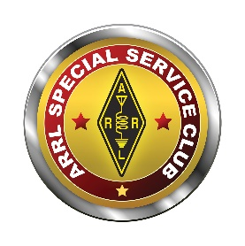  www.arrl.org | 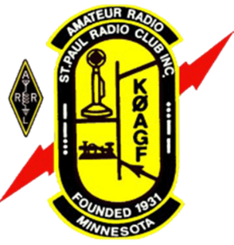 | St. Paul Radio Club  Ground Wave  Dan Meyer, NØKFB, Editor  Dale Maroushek, NØPEY, Publisher | KØAGF  www.stpaulradioclub.org  Club Repeaters:  145.310 MHz, 442.450 MHz  Each needs a 114.8 Hz tone  PO Box 9375  North St. Paul, MN 55109
SPRC Nets: Wednesdays 7:30 PM 28.310 MHz USB; 8:30 PM 145.310 MHz FM 114.8 tone
NEWS AND NOTES FOR OCTOBER 2022 – Volume 82, Issue 10
NEXT MEETING: FRIDAY October 7, 2022
6:00 PM Board Meeting (all are welcome to attend and observe)
7:00 PM Refreshments and Socializing
7:30 PM Membership Meeting Followed by Program
Entrance to CDH for our meeting
Meetings are held at Cretin-Durham Hall High School on Hamline Ave and Randolph Ave in St. Paul. Park in the lot off Hamline Ave near the athletic field. Enter door 21 at the Ryan Stem Center addition. The meeting room is down the hallway on the right (the Commons). Door 21 will lock at 7:45 so if you arrive after that, please call Br Bob to let you in: 612-201-0818
Activity in the athletic fields during the evenings of our September and October meetings are scheduled to end around 6:30 PM. This will affect parking for people arriving early for board meetings.
Program
Our meetings are hybrid meetings. That means there will be an in-person meeting at Cretin-Durham Hall (CDH) and a meeting on Zoom for those unable to attend in person. Zoom details are at the end of the newsletter.
Dave Ellison W7UUU will provide the program titled: "Shack Fire & Rebirth: Building the Ideal Modern Shack"
This program graphically tells the story of a massive shack fire at W7UUU back in October 2020. While the structure was saved, all of the contents were destroyed, including almost 50 years of collecting and restoring vintage as well as modern amateur radio gear. We then cover the complete rebuilding, with many practical and creative ideas that can be implemented in almost any shack. Along the way I cover several very important safety lessons learned, and how viewers can avoid the mistakes I made that led to my own disaster.
Dave Ellison W7UUU has been a ham radio operator since 1974, almost continuously active in the hobby for almost 48 years. He holds an Extra Class license earned back in the 1990s, and is very active in almost all aspects of the hobby including CW, FT8, contesting, homebrewing, and restoring vintage ham gear. Dave is a two-term past president of The Radio Club of Tacoma W7DK and resides in a rural area outside of Port Orchard, Washington.
The Prez Sez…
I am still a little amazed that I am writing this column. I never really intended to run for President, but in my head, I heard that old disaster lament “Somebody Should DO SOMETHING”. Once again, the my brain answered “If not me, then who?” So here I am! Impetuous, ill-equipped, but here I am, gavel in hand. There was some logic in my decision, and I want to get to that by starting out by saying thank you to those who have worked tirelessly, for so many years, to keep this club together and moving forward.
That list must start with Dale Maroushek - NØPEY. Dale has held several offices in this club over the years. His presence at Field Day is almost an institution. He watches over the membership, which involves a ton of work, the Auction wouldn’t happen without his work. He quietly works with SK families taking down stations and advising them on the disposal of equipment. Net Master of the 10m Friendly Net and often of the SPRC 2m net. I unfairly lean on him to help me keep this club president working.
In that same vein, stands Don Kelly - WA6ZMT. Past President, our club parliamentarian, Oxford scholar, another main “guy stake” in the field day operation and the reason we have a Zoom meeting presence. Did I mention he new role as ARRL MN Section Affiliated Club Coordinator? Don’s unending creativity and good humor, has already helped me make the much-needed updates to the Club Brochure.
George Power - KØGCP is next. Field Day, the Auction, now Club Treasurer, George is a constant. I have worked events with George, one that turned particularly nasty. He adapted, improvised and overcame a situation, that was rapidly “circling the drain,” with a speed and ingenuity that amazed me. A detail guy that has ready answers to my many questions.
Kevin Welna - W5LNA Vice-President. Field Day ‘guy stake” successfully took over the field day chef position from Dale, (no small task) who truly earned the right to retire from that particular office. Resident builder, experimenter and good humor vice-president that can be relied upon to “step-up” when needed.
Jay Maher - NJØM in charge of Meeting Refreshments, we all take for granted and I personally appreciate greatly, food for the Christmas Party, Chair of the Annual Banquet, another of my favorite events Jay is also a Presenter (I still want to build that reflow oven), experimenter, a great Ham radio operator and all-around good guy.
Art Thell - NØIWQ Club secretary and expert in many things the board has to deal with. A hard worker at field day during setup. I respect and appreciate his council on all things to do with the board. Let’s face it, anyone with 6700+ lookups in QRZ is a great operator.
Brother Bob Walsh – WCØJ What can you say about Brother Bob except WOW, Just WOW. If God build a dynamo, it would be Brother Bob. This man accomplishes more in retirement that most of us did in our everyday jobs. This, just from my exposure to his work with the Club. Our wonderful meeting place and auction site along with all the accoutrements that go with, we owe to Brother Bob. I am always happy to see him on field day, because I know things will get done with a quiet smile and energetic hand.
Ben Otto – KEØRFZ, I enjoy his presentations, proving that you can indeed teach an old dog new tricks,. Our quiet technologist, who knows and shares his knowledge with the club. A “new brick in the wall”, we are happy he is here and on the board.
Pete Guldan – KDØSQJ Field Day Chairman. Responsible for securing a great site for the event, expending many personal hours on planning and managing the event and calculating the score (no small task.) Another quiet, hard worker, that forms a brick in the wall, upon which the club rests. Field day was one of the things that drew me to this club and Pete continues this fine club tradition, teaching us it’s about friendship and family, not necessarily points.
I am the president, but I am also a club member. I selected the SPRC years ago, after watching other clubs shrivel and nearly die. A sociology class I took explained why clubs of all types, not just radio clubs, were dying. The SPRC wasn’t afflicted with that particular “disease”. The wall upon the club is built continues to be made of caring people, not afraid of a little work, building something bigger than themselves. I call them friends.
BTW, The St. Paul Radio Club’s ARRL association anniversary is coming up. November 2, 1931. That makes us the oldest club in the Twin Cities. The reason, I think, is obvious.
Ralph Bierbaum N0AWN
Refurbishing Headphones by Scott N0AR

Most all our headphones have earpieces that are made of an artificial leather material or foam. While being very comfortable to wear they tend to fall apart over time. So if you find yourself picking little chunks of headphone out of your ears don’t toss that favorite set out just yet. Most headphone cushions either mount in a grove around the speaker or are glued on by double sided tape. Either way there is a replacement that can be had for a minimal cost. Some cushions are supported by the manufacture and a quick visit to their web site might reveal a replacement. If not drop a note to their customer service department and see if they support the needed replacement part. Lastly there are many different vendors of cushions that sell their replacements on Amazon. A quick search of “headphone replacement cushions” will put you in the ballpark for finding yours. If you can’t fine the exact model a generic replacement maybe just what you need. The critical dimensions are the diameter of the cushion and it’s shape, round or oblong. Most of the vendors show pictures and dimensions of their replacement pads. It’s easy to install the new cushions, clean off the old one and put the new on. You’ll be good for a few more years to come.

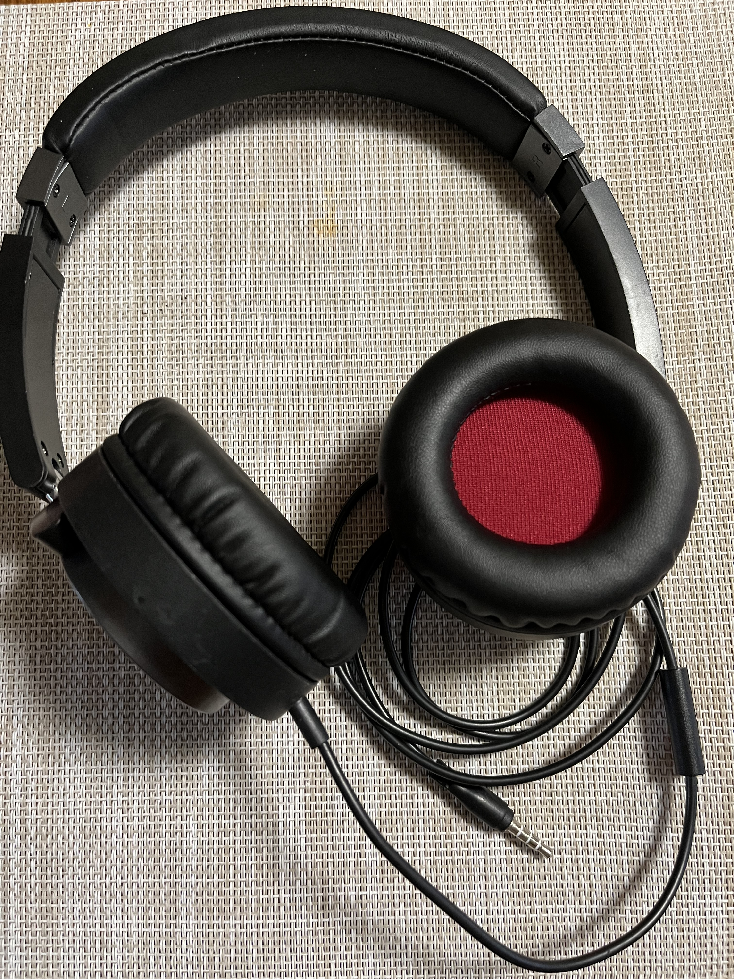
Here’s a set I replaced for a
grand total of $8. I even had a choice of the color!

Dale’s Details by Dale Maroushek NØPEY
Time to change the calendars again. I usually keep the current and next month pages showing so I can plan ahead with a quick glance. Plus I get two new pictures monthly.
Picking up from the September meeting, which I thought went very well including the fine program by Ralph, the MARC breakfast grew to nine on the third. Like the SPRC breakfast, Ronda the waitress tries to remember everyone’s order without writing them down. So I’ve been changing my selection each month, just to see how they do.
On the tenth, MARC and others did a day in a Park with a couple antennas and a radio for talking to anyone who could hear us. It was the Worked All Europe event, so mostly we heard CQ DX Europe. Of course we had to eat, so I brought out the auxiliary kitchen and we enjoyed burgers, pork chops, shrimp, onions and mushrooms for lunch and dinner.
On the seventeenth, we had to make a choice, breakfast or Hamfest at Bob’s. I was supposed to help Ken the former N0PEZ, sell his gear, but he had to go to a funeral. So I did a walkabout and visited the circle three times, finding a VCR and a clock. Good to see Reverend Rolph back in town for a visit and many others from the area. Some nice old gear was priced right if you needed to add to your collection.
The 24th is TCFMC fest, but I have some family events going, so I’ll miss that one too. Then it’s back to MARC breakfast on the 1st.
I called back my professional landscape team that helped get my project half done before I had the trees cut down this spring. The neighbor and I have tinkered with the frontier between the houses that I got us started on last year, with not the best results. So we discussed a plan that worked for both of us and I had the men go to town on it. Took two guys three days to get it finished so we can do the fine tuning ourselves now. He replaced the fence we took down and I have lots of flowers to replant in three areas. Unfortunately, now that I have a new path along the north side to drive on, I have to go back to the south side with the other neighbor and redo that frontier too. I keep finding the irrigation tubing, with the tiller, not good. And we also found a sprinkler head which is now buried in the new path. I did get one night for a burning event that got rid of one small pile of brush and a good chunk of the old deck boards. Ten or twenty more fires should get it all cleaned up.
One pleasant surprise was getting two Ryobi 4 cycle motors up and running without a great amount of problems. I also picked up a third one so I can have different tools on each one. Tillers, high reach chain saw, hedge trimmer and straight and curved weed trimmers. They have been sitting for a couple years, but a quick cleaning with carb spray and clean fuel got the two originals going. So, although I have some carb parts for those little things, a check on the web found replacement carbs with hoses and filters for under $20. Far too inexpensive to mess with rebuilding them. One other 2 cycle unit to get going and the fleet will be ready for fall take down. Also got the mulching kit for the tractor, so maybe I won’t have to make so many passes grinding up the flowers, lawn and leaves.
Someplace in the next month or two, I need to get antenna work planned, pieces of the puzzle found and staged, connectors put on cables, and inviting some helpers/learners over to get that job going. Sure would be nice to have the rotor work and the 160M OCF and another wire up for the winter.
Dale, N0PEY
HELP WANTED
Needed:
a VE Liaison for your St. Paul Radio Club – someone to coordinate the amateur radio exam sessions.
Currently, our exam year runs September through June with a session on the first Saturday of each month, plus an additional session in conjunction with the MAGIC Repeater Tailgater in July. All sessions are being held at Galilee Lutheran Church in Roseville at 9:30 am.
No experience is necessary, as you will be provided with on-the-job training, for a whole year if you act now. I got this position with no previous experience, but merely a willingness to help out the club. The person for this position needs to be 18 years of age or older; and never have had your amateur station or operator licenses suspended or revoked; and hold a valid Amateur Extra class license; and be an accredited ARRL Volunteer Examiner. To become a VE, you merely have to take an open book exam from the ARRL, and you don't even need to purchase a manual, as it's all online. You don't even need to be a member of the ARRL.
We currently have a large team of experienced VEs who help out with the monthly exams, so anyone volunteering for this position will have plenty of help. The time commitment for this position is about 2 - 3 hours per month plus the exam sessions themselves, which are typically another 2 hours. All paperwork / forms and instruction on their use will also be provided. This is a great opportunity for someone to help out the club with this important position. Please consider doing this. Contact Leon, WØCOE, with your willingness to help or with any questions by sending an email to w0coe@arrl.net, or contact any of the club officers.
Ramblings from the VP’s Work Bench - Kevin Welna - W5LNA
By the time you read this, temps will have fallen, and Fall will be upon us!
I'm still moving into the new house. We still have a few things left to get out of the old house and then after a coat of paint it will finally be on the market. My CW Ops class is in full swing, and I do believe I am improving. They changed the curriculum and now we are listening at 30 -35 words per minute with a Farnsworth of 8 to 12 words per minute. Believe it or not, it is actually easier to decode each letter at these speeds. Again, if you are interested in learning Morse Code, I cannot recommend this class enough! It is the best and easiest way to learn morse code and its FREE!
I still do not have any HF antennas on my roof, but that should be rectified the end of October. Currently I am amassing all the hardware and components needed for this last project before the snow flies. (Sorry for using that 4 letter word) Once done, I just have to sucker my son and son in law into climbing up on the roof and bolting it all down.
The shack is now basically done with the exception of the antennas. I think it turned out OK. Since the bench has a soldering station, I think it is only right that I build a few Electronics projects this winter. I will be starting with the CW Code Messenger outlined in Jack Purdum’s book “Microcontroller Projects for Amateur Radio”. This is an excellent book with lots of different Ham radio projects. Plus, there is a user group you can join to ask questions should you encounter and problems.
This should be a bit of an adventure for me, as I will be using one of the free cad programs to design the circuit board and then send it in to be made. The project only has about 15 components and the software for the Arduino ESP 32WROOM is already written and beta tested. The project should cost about $30. Some of the cool features are a touch screen for programming messages on the fly and navigating the menus, the capacity for storing up to 10 preprogramed messages, messages can be programmed by either a computer or the touch screen. It also functions a keyer! And is adjustable from about 5 to 100 Words per minute. With a battery for power it would be a great addition to any field activation like POTA. Hmm, Maybe we can design the enclosure to include a LIPO battery and charging circuit…. If you are interested in building this with me, buy the book listed above and call me so we can arrange a time to get together or at least converse over the phone\radio and start designing the circuit board. I will be starting on this project some time after the first of the year.
Just an FYI, I learned my lesson last year on the PIXI project…(Only 4 of the 30 given away were ever built and two of them by me….). With that being said, I will not be providing any components except for 3D printing the enclosure once you have completed the build. So, you will be on your own for acquiring components. Part of the process is learning where to find and purchase the components. Hint: It can all be found on Amazon. Although doing a group buy for parts is not off the table should enough people commit to building this project.
I still have not heard what the MN ARTS winter project will be, but I will keep an ear open.
I believe I did secure a presenter for after the first of the year. Pretty interesting, a club in Pennsylvania sent up a balloon with a Wisper (I think) transmitter and then tracked the balloon as it circumnavigated the earth. I believe they also logged a contact at around 5000 miles using 100 milliwatts of transmitting power. (If I remember correctly.) It did make it all the way around the earth and is now on its second circumnavigation. They did this project with the Boy Scouts for a STEM project. Pretty Cool , huh? Here is a video: https://www.youtube.com/watch?v=hAKtX23GLRI Maybe this is something we can try with CDH STEM? We might be able to team up with the Pennsylvania club to learn how and then launch our own balloon(s)? May be get a local TV station to cover this? It would be great publicity for the club and school…. Just some thoughts. Anyone interested in taking this on as a club project of some sort? Does any one else have an idea for a club project? Please let me know.
I have attached a few pictures of my shack. It’s still a work in progress and I have a lot of stuff to put away and arrange. How about sending in a picture of you bench\shack with a description? Its always fun to see someone else’s set up and bench layout.
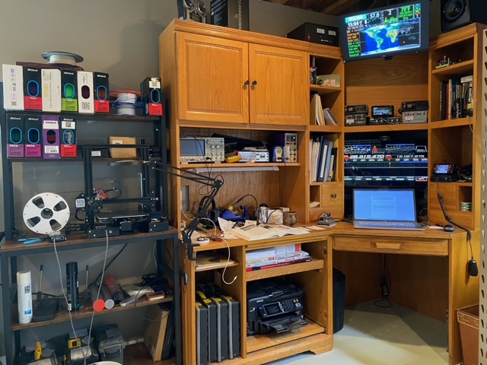
The radio desk and soldering bench and 3D printer
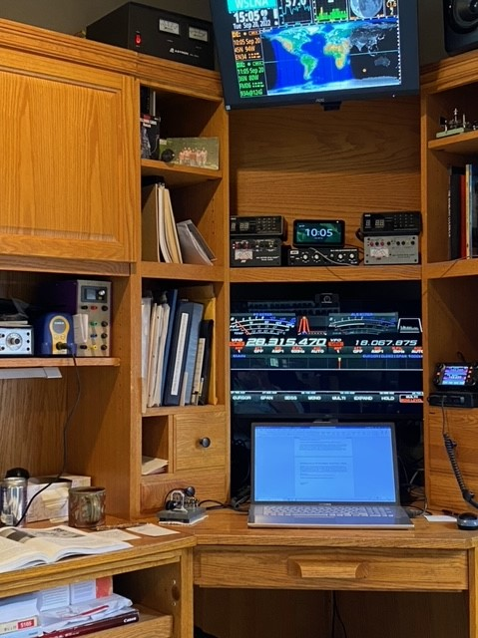 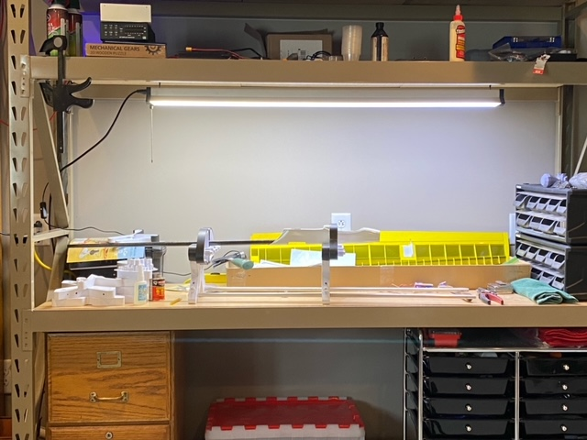
Close up of the bench Model Plane bench
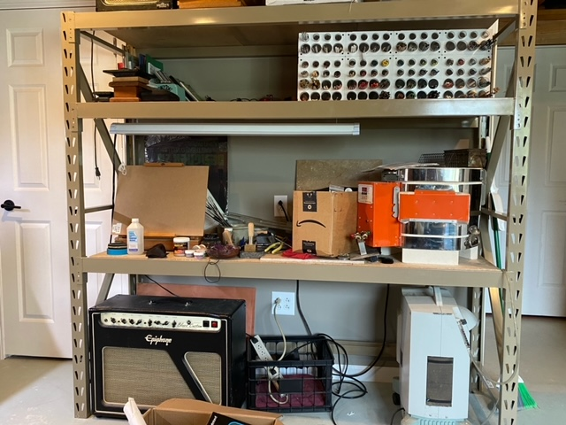
Glass blowing/lampworking, airbrushing and music bench.
I told you I have hobby ADHD!!!
That’s it for now.
Our next meeting will be on October 7^{tth} I believe…..Hope to see you there!
Till then: May your signals be strong and your antennas have extra gain….73
Kevin Welna VP W5LNA
September Board Meeting Minutes – by Art Thell, NØIWQ
St. Paul Radio Club
Board Meeting Minutes
09-09-2022

Board members present, (Absent or virtual):
Ralph Bierbaum (Pres.)-NØAWN Kevin Welna (V. Pres.)-W5LNA
Art Thell (Secy.)-NØIWQ George Power (Treas.)-WØGCP
Br. Bob Walsh-WCØJ Ben Otto-KEØRFZ (exc.)
Lou Michaels (Past Pres.)-WD8NOV (exc.)

Also present:
Don Kelly-WA6ZMT Dale Maroushek-NØPEY Jay Maher-NJØM
John Crabtree-KCØG Pete Guldan-KDØSQJ Bill Lippert-ACØW (Z)

6:12 pm
President, Ralph called the meeting to order.

Treasurer, George initiated a discussion regarding banking. Result:
- Secretary will draft a resolution giving the Treasurer all banking privileges and duties including access to (U. S. Bank) banking records. This draft will be submitted to board members for their input and consideration for adoption at the next board meeting.
- Treasurer will consolidate all banking through one checkbook. He has designed a spreadsheet journal for tracking income and expenditures on an ongoing basis. Treasurer has also produced a form by which members will formally request reimbursement for personal funds expended for the purposes of the club.
- Recommendation was that the Treasurer and President are to be authorized to sign checks. Not meant to require co-signature.
- Recommendation was that resolution approval be done by email for expediency.

Current account balances:
General: $6614.41 Repeater: $1014.25 Education: $1402.00

Field Day detail: Food $540.84 Gas $189.10
Porta Potty $155.70 Benson’s donation $100.00

Secretary, Art moved that the board approve the May minutes as published in the Ground Wave. Seconded by Kevin. Passed.
He also reminded members (esp. directed at new members) to find excuses to operate such as POTA, Special Events, & others.

Vice President, Kevin reported that a CW. ops unit in PA sent up a high altitude balloon that circumnavigated the globe at about 70-80,000 ft. altitude. In transmitting at 100 mw, the best distance was 5000 miles. He will pursue this for a presentation.

Membership Chairman, Dale indicated that the SPRC Brochure needs updating. Ralph accepted that duty. Dale reported that the current paid membership for 2022 was 135, unchanged from the reported 2021 membership.

The Club Membership Application has had issues. Ralph has begun a modification. To aid in that, Art has forwarded a workable form for him that SEMARC currently uses.

At Large Br. Bob reminded us of the Tech classes on MEA weekend, Oct. 21-23. Discussion began regarding manuals.

Vice President, Kevin Moved to have the club purchase 10 manuals from ARRL. George seconded the motion. Passed. Also a reminder that the ARRL will reimburse all but $5 of the cost for age 18 and under.

Pres. Ralph mentioned that the SPRC Website needs work. He will research and contact Tom Bredemus who has now indicated he is quite well mended from his ailments.

Art moved to adjourn & George seconded.

7:10 Adjourn

September Membership Meeting Minutes – by Art Thell, NØIWQ

St. Paul Radio Club
Member Meeting Minutes
09-09-2022 7:00 pm

7:33 Call to order by President Ralph Bierbaum

25 Members present plus Zoom.

Ground Wave Editor: Dan Meyer, NØKFB has agreed to be our new Ground Wave Editor.
Thank you Dan!

Kevin: Reported on the CW. ops Pennsylvania Balloon project.
He also is proposing a build project CW Keyer. Contact him if you are interested.

Art: Reminded members of the SEMARC Air Mail Special Event KØA this weekend.
Modes SSB, FT8, & CW.

Pete, KD0SQJ: Tech course and exam MEA weekend October 21-23. Test at noon, Sunday.
Calling for instructors.
Members recruit candidates.

Club Breakfast: Third Saturday, 9:00, September 17 at Denny’s on University Ave.
Across from the AxMan.

Move to adjourn, Jay. Seconded by George

Adjourn: 7:53

Editor’s Notes – by Dan Meyer, N0KFB
I am the new editor of the Ground Wave. If you have any articles to share please send them to dan@meyer-family.net and I will include it in the Ground Wave at the next opportunity. Please put your name in the filename of the article to help me keep things organized.
If you are on Facebook, please join our Facebook group. Let us know what you have been doing.
We have close to 150 members there.
Officer Contact Information
President | Bierbaum, Ralph, NØAWN | rwbierbaum@comcast.net | 612-201-9510
Vice President | Welna, Kevin W5LNA | kwelna@gmail.com | 651-354-5515
Past President | Michaels, Lou WD8NOV | louthephotoguy@gmail.com | 612-638-8159
Treasurer | Power, George KØGCP | georgecpower@gmail.com | 651-233-3215
Secretary | Thell, Art NØIWQ | thellaj@comcast.net | 651-492-0254
Member At-Large | Otto, Ben KEØRFZ | ke0rfz@gmail.com | 651-352-9590
Member At-Large | Walsh, Bob WCØJ | brw.fsc@gmail.com | 612-201-0818

SPRC Calendar

Sat Oct 1 9:30 AM VE testing. Galilee Lutheran Church. 145 N McCarrons Blvd, Roseville, MN 55113.
Reservations required. No walk-ins until further notice.
Contact Leon Dill, WØCOE@arrl.net or 651-425-0338.
Fri Oct 7 6PM SPRC Board meeting, Commons Meeting Room,
John R. Albers Center, Cretin-Derham Hall High School. *
Fri Oct 7 7PM Socializing followed by 7:30 PM SPRC Membership meeting.
Commons Meeting Room, John R. Albers Center, Cretin-Derham Hall High School.
Sat Oct 17 9AM SPRC Breakfast. Denny’s, 1664 University Ave, west of Snelling.
Fri Nov 4 6PM SPRC Board meeting,
Commons Meeting Room, John R. Albers Center, Cretin-Derham Hall High School. *
Fri Nov 4 7PM Socializing followed by 7:30 PM SPRC Membership meeting.
Commons Meeting Room, John R. Albers Center, Cretin-Derham Hall High School.
Sat Nov 5 9:30 AM VE testing. Galilee Lutheran Church. 145 N McCarrons Blvd, Roseville, MN 55113.
Reservations required. No walk-ins until further notice.
Contact Leon Dill, WØCOE@arrl.net or 651-425-0338.
Sat Oct 17 9AM SPRC Breakfast. Denny’s, 1664 University Ave, west of Snelling.
* Depending on business to be considered, Board Meetings are sometimes held electronically.
Check with a Board member beforehand to confirm a meeting.

Zoom Meeting Information
Simply click the link below (or copy and paste link into your browser if that doesn’t work) or call in from any phone.
If you’re not familiar with Zoom and would like to arrange to practice, text Don at 651 276-4838 or email dk@donkelly.biz.
Saint Paul Radio Club is inviting you to a scheduled Zoom meeting.
Topic: SPRC Monthly Meeting
Time: Oct 7, 2022 06:00 PM Central Time (US and Canada)
Oct 7, 2022 06:00 PM
Nov 4, 2022 06:00 PM
Dec 2, 2022 06:00 PM
Jan 6, 2023 06:00 PM
Feb 3, 2023 06:00 PM
Mar 3, 2023 06:00 PM
Mar 31, 2023 06:00 PM
May 5, 2023 06:00 PM
Please download and import the following iCalendar (.ics) files to your calendar system.
Monthly: https://us02web.zoom.us/meeting/tZMlf-uvpz8uGdAS6IYyFBq9uL1cXxTVtmJ-/ics?icsToken=98tyKuGvpjMoHd2RtBqDRpwEGoqga-3xmClbjad8r0nMOjl1QBKvI84TMYpnJO7E
To Join the Zoom Meeting use this link:
https://us02web.zoom.us/j/87882794434?pwd=bGdueVVhNmZXVjQrRjFOL2tZMlhmZz09
or
https://tinyurl.com/2tyybeuc
Meeting ID: 878 8279 4434 Passcode: 6512764838
One tap mobile +13092053325,,87882794434#,,,,*6512764838# US
For audio-only, dial +1 312 626 6799 US (Chicago)
To find other dial-in numbers, see: https://us02web.zoom.us/u/kuWkJhGiz

